Game Engine Programming Template File Sample File: Note Initial Caps

**Student Number: 20021817**

*It is recommended to put a picture or something representative of outcome or process here.*

# Abstract

Updated 26/10/2023. In this sample document, we describe the formatting requirements for the Game Engine Programming reports (adapted from the final year Creative Technology report format), and this sample file offers recommendations on writing for the worldwide research readership. This template is based on the standard SIGCHI (Special Interest Group on Computer Human Interaction) ACM (Association for Computing Machinery) extended abstracts template.

# Author Keywords

Inventory; Unity; Unreal Engine; Object-Oriented Programming; Scriptable Object.

# Introduction to document

# (Delete before submission)

This format is to be used for submissions of reports for the Game Engine Programming module. We wish to give you a consistent, high-quality appearance and encourage students to experience writing for a wider research audience. We therefore ask that authors follow some simple guidelines. In essence, you should format your paper like this document.

The easiest way to do this is simply to download this template from the module blackboard website and replace the example content as necessary.

# Introduction

**Good Utilization of this Space Sample, as Side Bar**

**Preparation**: Do not change the text box size or position.

**Materials:** This should not appear higher or lower on the page because of pagination and specific headers added during the indexing and pagination process.

**Process:** A 0.75 inch rule is beneficial to break this apart from the body text. The text in this text box should remain the same size as the Body Text: 8.5 Verdana or Arial (with use of **bold** and *italics* to highlight points)

Brief description of the task you’ve undertaken and the implementations you’ve made.

The tasks presented is a research project into creating an inventory system for a third person game, within Unity and Unreal Engine.

# Background & Research

With references to lecture content and suitable technical and game specific literature, outline techniques you’ve used in your implementations and how they might be made part of a wider game as well as interact with the various sections of a game engine. Also any inspiration you’ve taken from existing games should be included here.

Document this as-you-go, or at least keep notes of research you are carrying out.

# Implementations

What shared aspects were there between each of your implementations. A section for each engine on how your system was implemented and which aspect of each game engine were required.

## Unity Engine Implementation

In Unity the implementation features a grid-based inventory system with dedicated item slots for tools and equipment. A crafting system to create upgraded items and a skill tree to unlock new abilities.

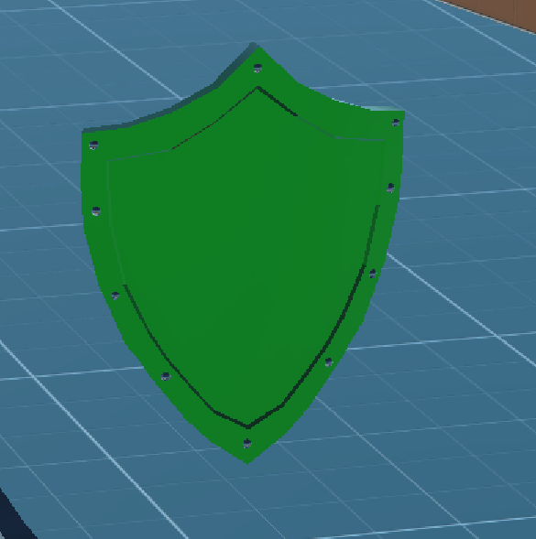Each Item has a game world game object which stores a scriptable object with all the information for the item. When one of these game objects is picked up by colliding with the player character the information is passed to the inventory.

The base inventory is made using a list which is dynamically adds to and removes items. Each item in the list is stored the scriptable object along with the quantity of that item the player is holding. The visual UI Inventory is a separate UI game object which is derived from a prefab and receives information from the scriptable object, including the item name and icon as well as the Item type.

In addition there are Item slots specific to tools and armour.

## Engine 2 Implementation

Outline principle features of your second engine’s implementation, and how you went about developing it.

# Evaluation

Evaluate your outcomes and your approach, suggest further improvements or directions.

* 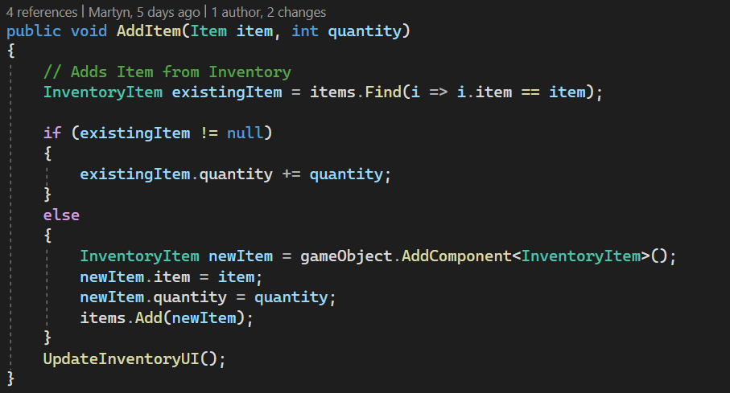What went well? What not so well? What could be improved?
* How does each engine weigh up to implement your system?
* How would this work as part of a wider game project?
* Compare and contrast between the engines used.

# Text formatting (Delete this section before submission!)

Please use an 8.5-point Verdana font, or other sans serifs font as close as possible in appearance to Verdana in which these guidelines have been set. (The “Normal” style for this document automatically gives you this font setting.) Arial 9-point font is a reasonable substitute for Verdana as it has a similar x-height. Please use serif or non-proportional fonts only for special purposes, such as distinguishing source code text.

## Text styles

The template uses MS Word text styles to facilitate text formatting. The applicable text styles are:

Normal – for body text

# Heading 1

## Heading 2

### heading 3

Caption & annotation (they’re the same)

Additionally, here is an example of footnoted text.[1] (the footnote is created with the “Insert Footnote” command under the “References” tab in Word). As stated in the footnote, footnotes should rarely be used.

## Language, style, and content

The written and spoken language of SIGCHI is English. For this module, please use British English, though other English styles will be accepted provided they’re used consistently. Hyphenation is optional. To ensure suitability for an international audience, please pay attention to the following:

* Write in a straightforward style. Use simple sentence structure. Try to avoid long sentences and complex sentence structures. Use semicolons carefully.
* Use common and basic vocabulary (e.g., use the word “unusual” rather than the word “arcane”).
* Briefly define or explain all technical terms. The terminology common to your practice/discipline may be different in other design practices/disciplines.
* Spell out all acronyms the first time they are used in your text. For example, “World Wide Web (WWW)”.
* Explain local references (e.g., not everyone knows all city names in a particular country).
* Explain “insider” comments. Ensure that your whole audience understands any reference whose meaning you do not describe (e.g., do not assume that everyone has used a Macintosh or a particular application).
* Explain colloquial language and puns. Understanding phrases like “red herring” requires a cultural knowledge of English. Humor and irony are difficult to translate.
* Use unambiguous forms for culturally localized concepts, such as times, dates, currencies and numbers (e.g., “1-5-97” or “5/1/97” may mean 5 January or 1 May, and “seven o'clock” may mean 7:00 am or 19:00).
* Be careful with the use of gender-specific pronouns (*he*, *she*) and other gender-specific words (*chairman*, *manpower*, *man-months*). Use gender neutral language where appropriate, such as when discussing general people or where individual gender is not (e.g., *they*, *chair*, *staff*, *staff-hours*, *person-years*) that is gender-neutral. If necessary, you may be able to use “he” and “she” in alternating sentences, so that the two genders occur equally often (Schwartz, 1995).

So long as you don’t type outside the right margin, it’s okay to put annotations over here on the right, too. Remember to use the annotation text style.

# Figures

# (Delete this section before submission!)

The examples on this and following pages should help you get a feel for how screen-shots and other figures should be placed in the template. *Be sure to make images large enough so the important details are legible and clear.*

If you aren’t familiar with Word’s handling of pictures, we offer one tip: the “format picture” dialog is the key to controlling position of pictures and the flow of text around them. You access these controls by selecting your picture, then choosing “… Format” tab above the ribbon at the top of the window.

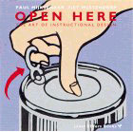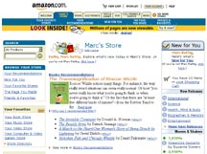

**Figure 1:** One good use of the narrow margin column: callouts that annotate a figure, either with text or a more detailed image.

**Figure 2.** Insert a caption below each figure. This figure is awful because it’s blurry and far too small to read. Make sure not to make this mistake in your report!

| **Column Head Samples** | **1** | **2** | **3** |
| --- | --- | --- | --- |
| Measurements result | 22.52 | 12.16 | 10.75 |
| CogTool prediction | 22.72 | 12.26 | 10.60 |
| CogTool error % | 0.009 | 0.008 | 0.014 |

**Table 2.** This sample table has the caption appearing below. Please use 0.75 rules/borders for your tables, align decimals or center text in the cells. For improved accessibility, header rows of tables should be marked. In Word, right click a header row, and select Table Properties | Row | Repeat as header at the top of each page.

|  | **Center column head** | **Center column head** |
| --- | --- | --- |
| child | 4.2 | 2.3 | 5.1 | 3.8 |
| older adults | 2.8 | 2.2 | 3.1 | 4.7 |
| Bob | 2.5 | 3.1 | 3.0 | 12.2 |
| Dave | **0.75 rules** | 2.5 | 3.2 |

**Table 1.** Sample narrow table in the left margin space.

As for the “picture” tab in that dialog, we recommend using Photoshop or other graphics software to scale images, rather than scaling them after you have placed them in Word. Word’s scaling tends to reduce the clarity and legibility of images more so than dedicated graphics software.

Figure 4 shows a treatment of large figures, too big to fit inside a single column of text.

All figures should include alt text for improved accessibility. In Word, right click the figure, and select Format Picture | Alt Text).

**Figure 3:** If your figure has a light background, you can set its outline to light gray, like this, to make a box around it. The column width is 8.5 cm (3.34”), so setting this picture to fill the column was easily done by right-clicking on it (option-click on the Mac), choosing “format picture,” then the “size” tab, and setting its width to 8.5 cm (3.34”).

# References and Citations

# (Delete this section before submission)

You should be using the UWE Harvard Referencing system as specified by the University Guidelines <https://www.uwe.ac.uk/study/study-support/study-skills/referencing/uwe-bristol-harvard>

Your references should be published materials accessible to the public. Internal technical reports may be cited only if they are easily accessible (i.e., you provide the address for obtaining the report within your citation) and may be obtained by any reader for a nominal fee. Proprietary information may not be cited. Private communications should be acknowledged in the main text, not referenced (e.g., “(Robertson, personal communication)”).

USE THE BUILT IN TOOLS IN WORD TO HELP YOU PRODUCE YOUR REFERENCE LIST!

**Figure 4:** A figure too wide to fit into a single column can be spread across both columns, like so. Figure shows Minecraft’s toolbar UI (Mojang Studios, 2023).

# Accessibility

# (Delete this section before submission)

The Executive Council of SIGCHI has committed to making SIGCHI conferences more inclusive for researchers, practitioners, and educators with disabilities. As a part of this goal, the all authors are asked to work on improving the accessibility of their submissions. Specifically, we encourage authors to carry out the following five steps:

1. Add alternative text to all figures
2. Mark table headings
3. Generate a tagged PDF
4. Verify the default language
5. Set the tab order to “Use Document Structure”

For more information and links to instructions and resources, please see:

<http://chi2014.acm.org/authors/guide-to-an-accessible-submission>

# Producing and testing PDF files

# (Delete this section before submission)

We recommend that you produce a PDF version of your submission well before the final deadline.

# Acknowledgements

We thank all the volunteers, and all publications support and staff, who wrote and provided helpful comments on previous versions of this document. As well authors 1, 2, & 3 gratefully acknowledge the grant from NSF (#1234-2012-ABC). Author 4 for example may want to acknowledge a supervisor/manager from their original employer. This whole paragraph is just for example … Some of the references cited in this paper are included for illustrative purposes only.

# References format

# (Delete this section before submission)

References must be the same font size as other body text. It will make things WAY easier if you use the built in reference tool in Word!

# References

Adobe (2023) *Adobe Acrobat Reader* (2023) [computer program] Available from: <https://get.adobe.com/reader/> [Accessed 26 October 2023]

Klemmer, R.S., Thomsen, M., Phelps-Goodman, E., Lee, R. and Landay, J.A. (2002) Where do web sites come from? Capturing and interacting with design history. In *Proc. CHI 2002*, ACM Press 2002, pp. 1-8.

Mojang Studios (2023) Minecraft [Video game]. Mojang Studios.

Schwartz, M. *Guidelines for Bias-Free Writing*. Indiana University Press, Bloomington, IN, USA, 1995.

1. Use footnotes sparingly, if at all.